**WEEK – 4**

**1. spring-rest-handson**

**Create a Spring Web Project using Maven**

**File Name :** **pom.xml**

<project xmlns="http://maven.apache.org/POM/4.0.0"

xmlns:xsi="http://www.w3.org/2001/XMLSchema-instance"

xsi:schemaLocation="http://maven.apache.org/POM/4.0.0

http://maven.apache.org/xsd/maven-4.0.0.xsd">

<modelVersion>4.0.0</modelVersion>

<groupId>com.cognizant</groupId>

<artifactId>spring-learn</artifactId>

<version>0.0.1-SNAPSHOT</version>

<packaging>jar</packaging>

<name>spring-learn</name>

<description>Demo project for Spring Boot</description>

<parent>

<groupId>org.springframework.boot</groupId>

<artifactId>spring-boot-starter-parent</artifactId>

<version>3.2.5</version>

</parent>

<properties>

<java.version>17</java.version>

</properties>

<dependencies>

<dependency>

<groupId>org.springframework.boot</groupId>

<artifactId>spring-boot-starter-web</artifactId>

</dependency>

<dependency>

<groupId>org.springframework.boot</groupId>

<artifactId>spring-boot-devtools</artifactId>

<scope>runtime</scope>

</dependency>

<dependency>

<groupId>org.springframework.boot</groupId>

<artifactId>spring-boot-starter-test</artifactId>

<scope>test</scope>

</dependency>

</dependencies>

<build>

<plugins>

<plugin>

<groupId>org.springframework.boot</groupId>

<artifactId>spring-boot-maven-plugin</artifactId>

</plugin>

</plugins>

</build>

</project>

**File Name : SpringLearnApplication.java**

package com.cognizant.springlearn;

import org.springframework.boot.SpringApplication;

import org.springframework.boot.autoconfigure.SpringBootApplication;

import org.slf4j.Logger;

import org.slf4j.LoggerFactory;

@SpringBootApplication

public class SpringLearnApplication {

private static final Logger LOGGER = LoggerFactory.getLogger(SpringLearnApplication.class);

public static void main(String[] args) {

LOGGER.info("START");

SpringApplication.run(SpringLearnApplication.class, args);

LOGGER.info("END");

}

}

**File Name : HelloController.java**

package com.cognizant.springlearn;

import org.springframework.web.bind.annotation.GetMapping;

import org.springframework.web.bind.annotation.RestController;

@RestController

public class HelloController {

@GetMapping("/hello")

public String sayHello() {

return "Hello from Spring Boot!";

}

}

**File Name : application.properties**

# Change to an available port

server.port=9191

OUTPUT:

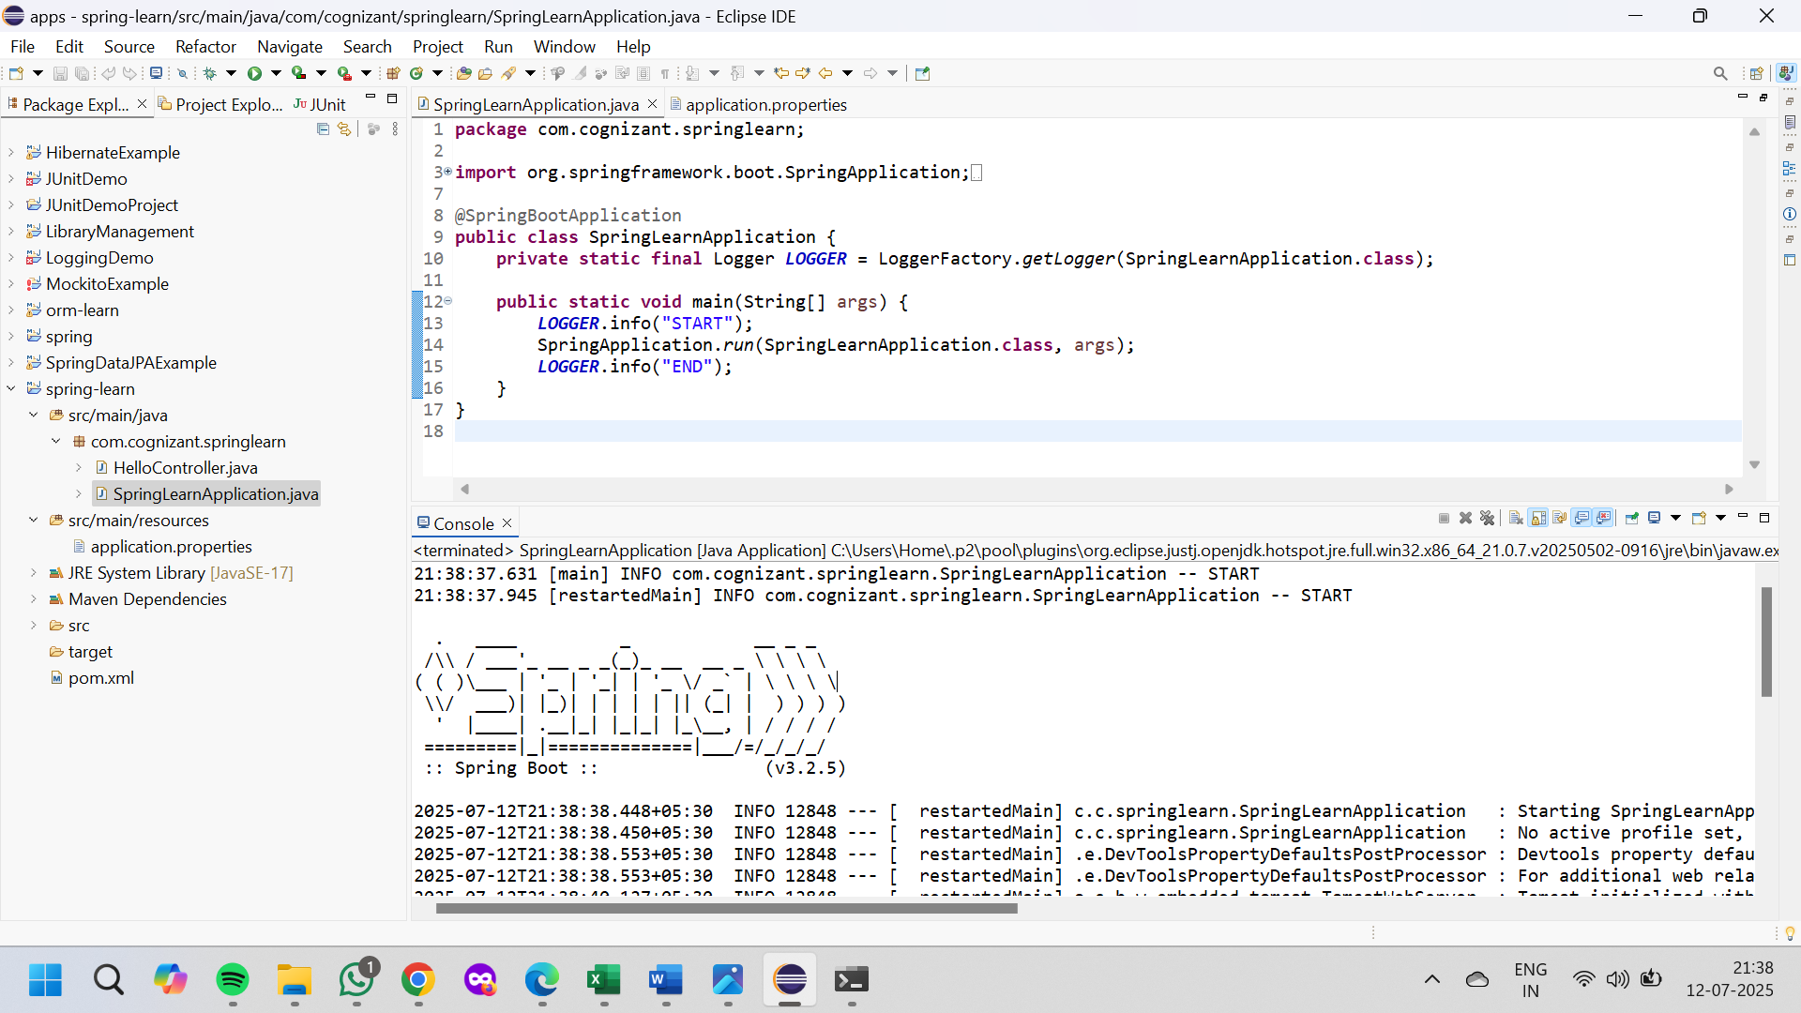

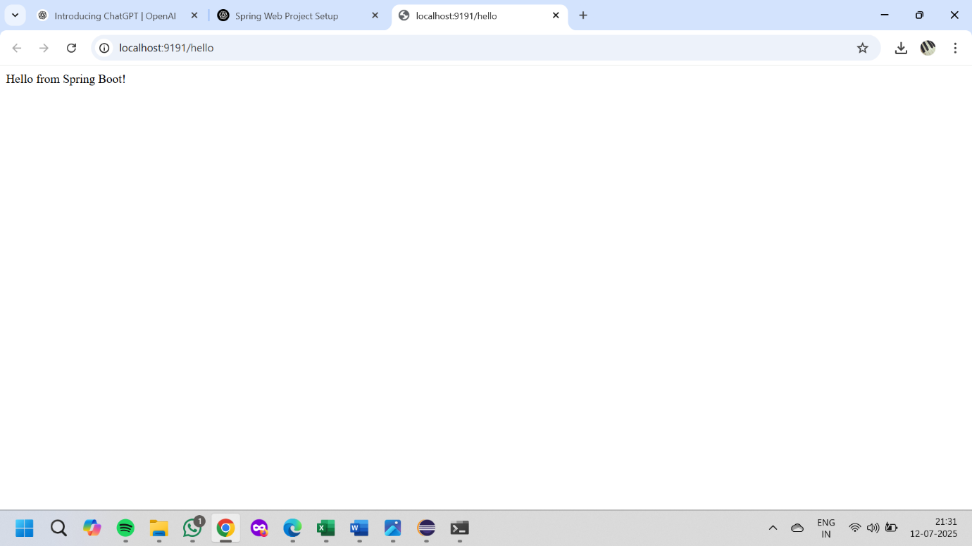

**Spring Core – Load Country from Spring Configuration XML**

**File Name : Country.java**

package com.cognizant.springlearn;

import org.slf4j.Logger;

import org.slf4j.LoggerFactory;

public class Country {

private static final Logger LOGGER = LoggerFactory.getLogger(Country.class);

private String code;

private String name;

public Country() {

LOGGER.debug("Inside Country Constructor.");

}

public String getCode() {

LOGGER.debug("Inside getCode()");

return code;

}

public void setCode(String code) {

LOGGER.debug("Inside setCode()");

this.code = code;

}

public String getName() {

LOGGER.debug("Inside getName()");

return name;

}

public void setName(String name) {

LOGGER.debug("Inside setName()");

this.name = name;

}

@Override

public String toString() {

return "Country [code=" + code + ", name=" + name + "]";

}

}

**File Name:** **country.xml**

<?xml version="1.0" encoding="UTF-8"?>

<beans xmlns="http://www.springframework.org/schema/beans"

xmlns:xsi="http://www.w3.org/2001/XMLSchema-instance"

xsi:schemaLocation="http://www.springframework.org/schema/beans

http://www.springframework.org/schema/beans/spring-beans.xsd">

<bean id="country" class="com.cognizant.springlearn.Country">

<property name="code" value="IN"/>

<property name="name" value="India"/>

</bean>

</beans>

**File:** **SpringLearnApplication.java**

package com.cognizant.springlearn;

import org.slf4j.Logger;

import org.slf4j.LoggerFactory;

import org.springframework.context.ApplicationContext;

import org.springframework.context.support.ClassPathXmlApplicationContext;

public class SpringLearnApplication {

private static final Logger LOGGER = LoggerFactory.getLogger(SpringLearnApplication.class);

public static void displayCountry() {

ApplicationContext context = new ClassPathXmlApplicationContext("country.xml");

Country country = context.getBean("country", Country.class);

LOGGER.debug("Country : {}", country.toString());

}

public static void main(String[] args) {

displayCountry();

}

}

**File Name: pom.xml**

<dependencies>

<!-- Spring Core -->

<dependency>

<groupId>org.springframework</groupId>

<artifactId>spring-context</artifactId>

<version>5.3.30</version>

</dependency>

<!-- SLF4J for Logging -->

<dependency>

<groupId>org.slf4j</groupId>

<artifactId>slf4j-api</artifactId>

<version>1.7.36</version>

</dependency>

<dependency>

<groupId>org.slf4j</groupId>

<artifactId>slf4j-simple</artifactId>

<version>1.7.36</version>

</dependency>

</dependencies>

**OUTPUT:**

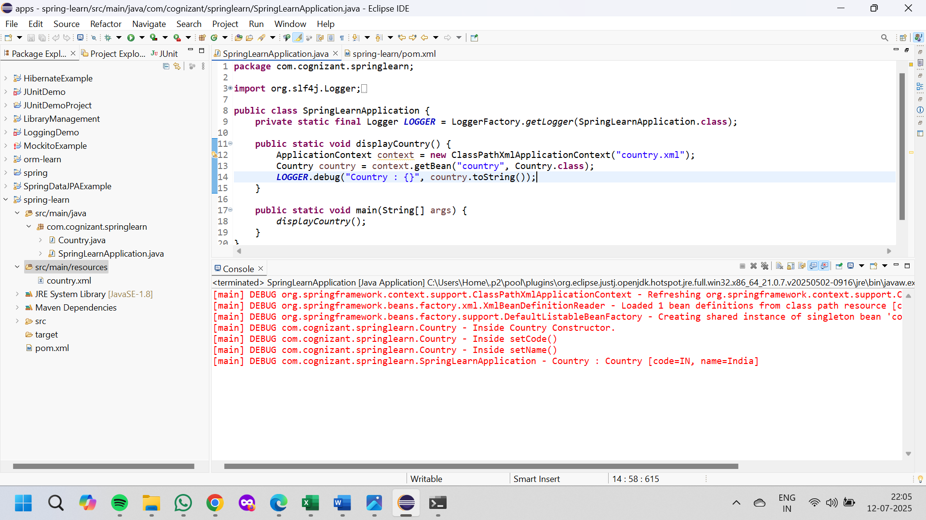

**2. spring-rest-handson**

**Hello World RESTful Web Service**

**File Name : HelloController.java**

package com.cognizant.springlearn.controller;

import org.slf4j.Logger;

import org.slf4j.LoggerFactory;

import org.springframework.web.bind.annotation.GetMapping;

import org.springframework.web.bind.annotation.RestController;

@RestController

public class HelloController {

private static final Logger LOGGER = LoggerFactory.getLogger(HelloController.class);

@GetMapping("/hello")

public String sayHello() {

LOGGER.info("START - sayHello()");

String message = "Hello World!!";

LOGGER.info("END - sayHello()");

return message;

}

}

**File Name : application.properties**

server.port=8083

**OUTPUT:**

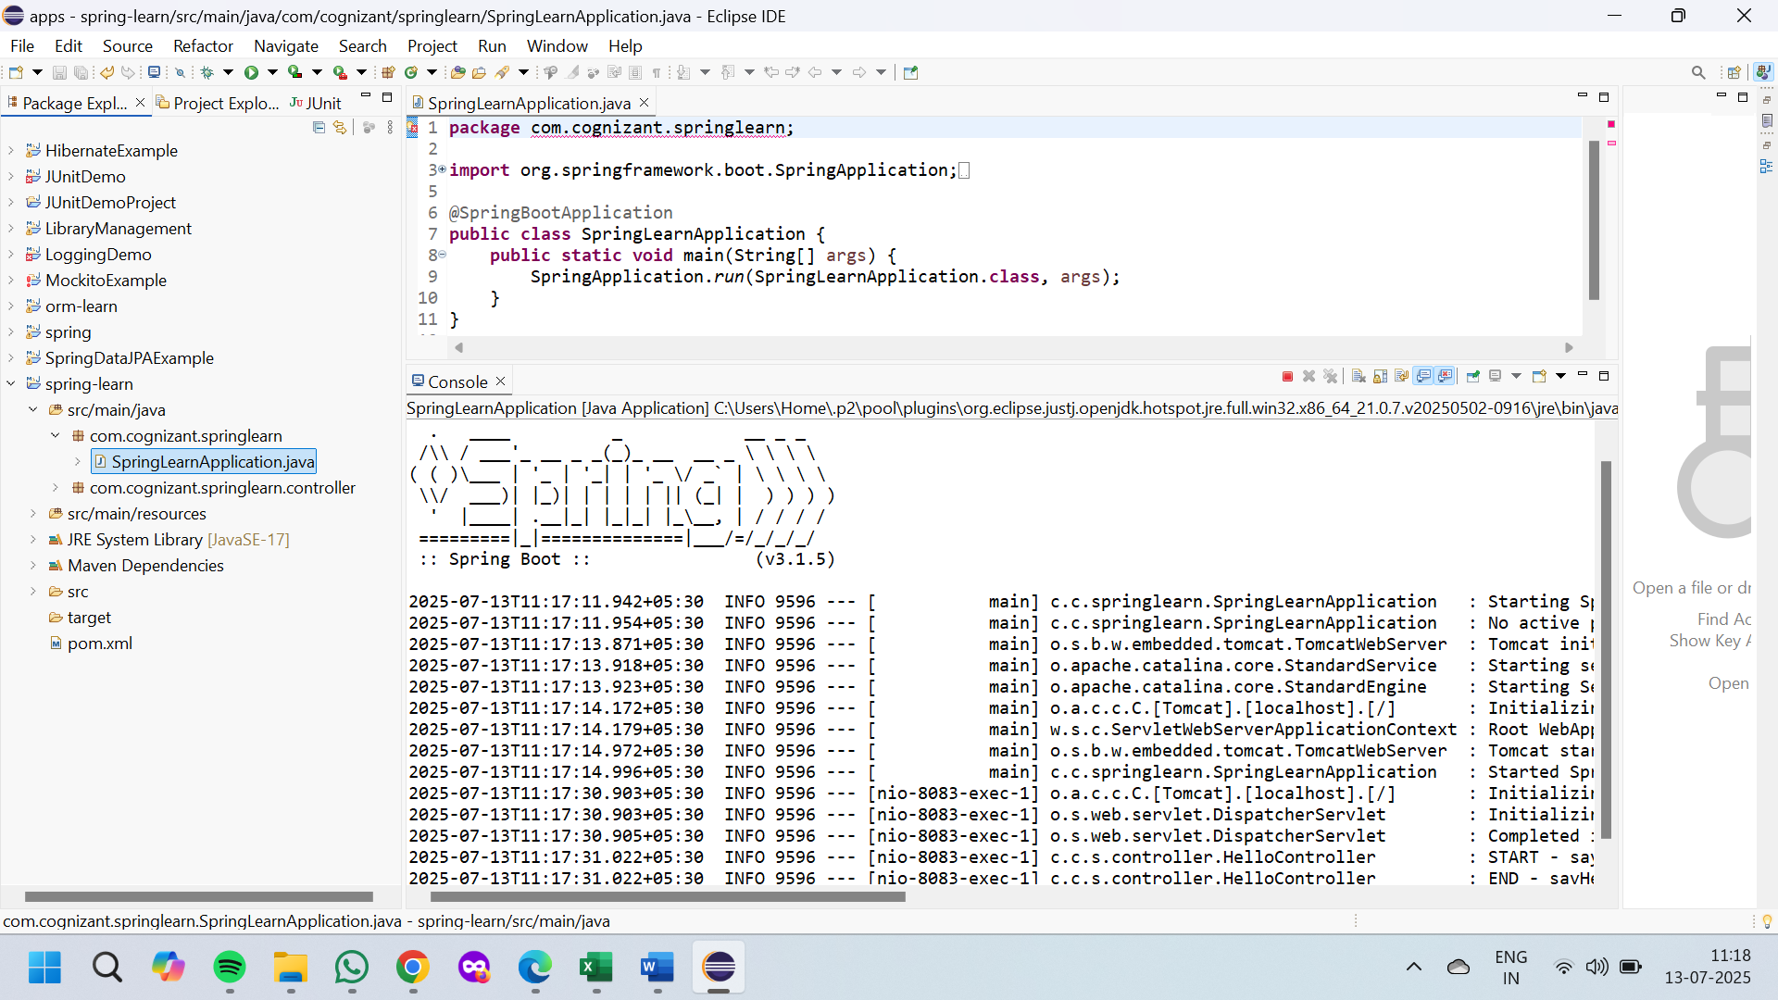

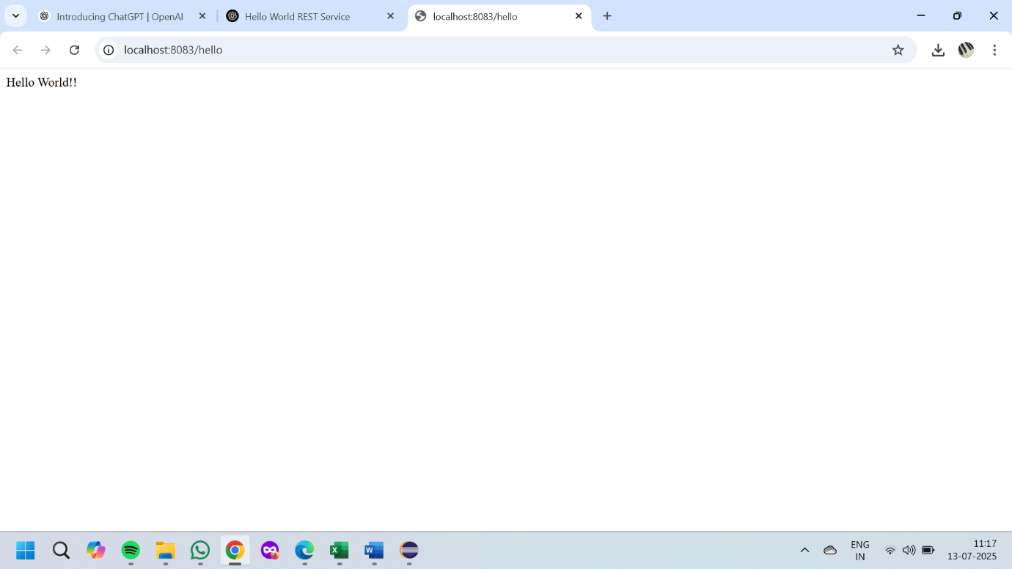

**4)Country web service**

**File Name:pom.xml**

<project xmlns="http://maven.apache.org/POM/4.0.0" ...>

<modelVersion>4.0.0</modelVersion>

<groupId>com.cognizant</groupId>

<artifactId>spring-learn</artifactId>

<version>1.0.0</version>

<dependencies>

<!-- Spring Boot Dependencies -->

<dependency>

<groupId>org.springframework.boot</groupId>

<artifactId>spring-boot-starter-web</artifactId>

</dependency>

<!-- Spring Boot XML Configuration Support -->

<dependency>

<groupId>org.springframework.boot</groupId>

<artifactId>spring-boot-starter</artifactId>

</dependency>

<!-- For XML-based bean loading -->

<dependency>

<groupId>org.springframework</groupId>

<artifactId>spring-context</artifactId>

</dependency>

<!-- Optional: DevTools -->

<dependency>

<groupId>org.springframework.boot</groupId>

<artifactId>spring-boot-devtools</artifactId>

<scope>runtime</scope>

</dependency>

</dependencies>

</project>

Country.java

package com.cognizant.springlearn.model;

public class Country {

private String code;

private String name;

// Getters and Setters

public String getCode() {

return code;

}

public void setCode(String code) {

this.code = code;

}

public String getName() {

return name;

}

public void setName(String name) {

this.name = name;

}

}

**File name:Country.xml**

<?xml version="1.0" encoding="UTF-8"?>

<beans xmlns="http://www.springframework.org/schema/beans"

xmlns:xsi="http://www.w3.org/2001/XMLSchema-instance"

xsi:schemaLocation="http://www.springframework.org/schema/beans

http://www.springframework.org/schema/beans/spring-beans.xsd">

<bean id="country" class="com.cognizant.springlearn.model.Country">

<property name="code" value="IN"/>

<property name="name" value="India"/>

</bean>

</beans>

**File name:CountryController.java**

package com.cognizant.springlearn.controller;

import org.springframework.beans.factory.xml.XmlBeanFactory;

import org.springframework.core.io.ClassPathResource;

import org.springframework.web.bind.annotation.RequestMapping;

import org.springframework.web.bind.annotation.RestController;

import com.cognizant.springlearn.model.Country;

@SuppressWarnings("deprecation")

@RestController

public class CountryController {

@RequestMapping("/country")

public Country getCountryIndia() {

XmlBeanFactory factory = new XmlBeanFactory(new ClassPathResource("country.xml"));

Country country = (Country) factory.getBean("country");

return country;

}

}

**File name:application.properties**

server.port=8083

output:

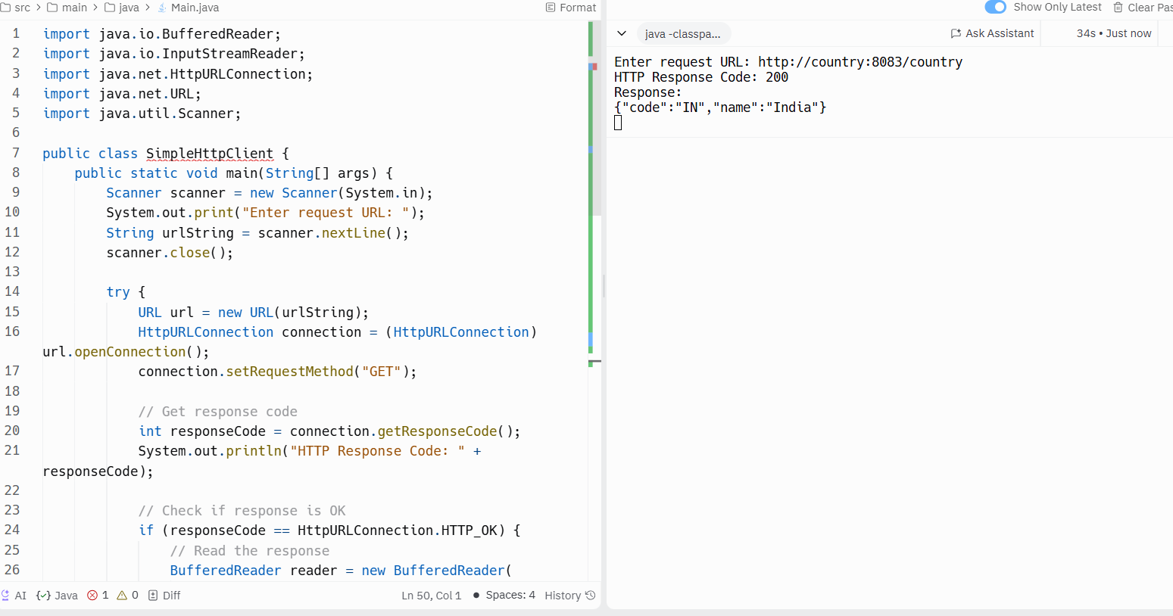

**5)REST - Get country based on country code**

**File name:Country.java**

package com.cognizant.springlearn.model;

public class Country {

private String code;

private String name;

public String getCode() { return code; }

public void setCode(String code) { this.code = code; }

public String getName() { return name; }

public void setName(String name) { this.name = name; }

}

**File name:Country.xml**

<?xml version="1.0" encoding="UTF-8"?>

<beans xmlns="http://www.springframework.org/schema/beans"

xmlns:xsi="http://www.w3.org/2001/XMLSchema-instance"

xsi:schemaLocation="

http://www.springframework.org/schema/beans

http://www.springframework.org/schema/beans/spring-beans.xsd">

<bean id="countryList" class="java.util.ArrayList">

<constructor-arg>

<list>

<bean class="com.cognizant.springlearn.model.Country">

<property name="code" value="IN" />

<property name="name" value="India" />

</bean>

<bean class="com.cognizant.springlearn.model.Country">

<property name="code" value="US" />

<property name="name" value="United States" />

</bean>

<bean class="com.cognizant.springlearn.model.Country">

<property name="code" value="FR" />

<property name="name" value="France" />

</bean>

</list>

</constructor-arg>

</bean>

</beans>

**File name:CountryService.java**

package com.cognizant.springlearn.service;

import com.cognizant.springlearn.model.Country;

import org.springframework.beans.factory.xml.XmlBeanFactory;

import org.springframework.core.io.ClassPathResource;

import org.springframework.stereotype.Service;

import java.util.List;

@SuppressWarnings("deprecation")

@Service

public class CountryService {

public Country getCountry(String code) {

XmlBeanFactory factory = new XmlBeanFactory(new ClassPathResource("country.xml"));

List<Country> countries = (List<Country>) factory.getBean("countryList");

return countries.stream()

.filter(c -> c.getCode().equalsIgnoreCase(code))

.findFirst()

.orElse(null);

}

}

**File name:CountryController.java**

package com.cognizant.springlearn.controller;

import com.cognizant.springlearn.model.Country;

import com.cognizant.springlearn.service.CountryService;

import org.springframework.beans.factory.annotation.Autowired;

import org.springframework.web.bind.annotation.*;

@RestController

public class CountryController {

@Autowired

private CountryService countryService;

@GetMapping("/countries/{code}")

public Country getCountry(@PathVariable String code) {

return countryService.getCountry(code);

}

}

**File name:SpringLearnApplication.java**

package com.cognizant.springlearn;

import org.springframework.boot.SpringApplication;

import org.springframework.boot.autoconfigure.SpringBootApplication;

@SpringBootApplication

public class SpringLearnApplication {

public static void main(String[] args) {

SpringApplication.run(SpringLearnApplication.class, args);

}

}

appliocation.properties

server.port=8083

**File name:pom.xml**

<project xmlns="http://maven.apache.org/POM/4.0.0"

xmlns:xsi="http://www.w3.org/2001/XMLSchema-instance"

xsi:schemaLocation="http://maven.apache.org/POM/4.0.0

http://maven.apache.org/xsd/maven-4.0.0.xsd">

<modelVersion>4.0.0</modelVersion>

<groupId>com.cognizant</groupId>

<artifactId>spring-learn</artifactId>

<version>1.0</version>

<dependencies>

<!-- Spring Boot Dependencies -->

<dependency>

<groupId>org.springframework.boot</groupId>

<artifactId>spring-boot-starter-web</artifactId>

</dependency>

<dependency>

<groupId>org.springframework.boot</groupId>

<artifactId>spring-boot-starter</artifactId>

</dependency>

<!-- For loading XML -->

<dependency>

<groupId>org.springframework</groupId>

<artifactId>spring-context</artifactId>

</dependency>

</dependencies>

<properties>

<java.version>11</java.version>

</properties>

</project>

Output:

**JWT HandsOn**

**6) Create authentication service that returns JWT**

**File name:AuthenticationController.java**

package com.example.jwt.controller;

import io.jsonwebtoken.Jwts;

import io.jsonwebtoken.SignatureAlgorithm;

import org.springframework.web.bind.annotation.GetMapping;

import org.springframework.web.bind.annotation.RestController;

import javax.servlet.http.HttpServletRequest;

import java.util.Base64;

import java.util.Date;

@RestController

public class AuthenticationController {

private static final String SECRET_KEY = "mysecretkey";

@GetMapping("/authenticate")

public String authenticate(HttpServletRequest request) {

String authHeader = request.getHeader("Authorization");

if (authHeader != null && authHeader.startsWith("Basic ")) {

// Decode base64 encoded credentials

String base64Credentials = authHeader.substring("Basic ".length());

byte[] credDecoded = Base64.getDecoder().decode(base64Credentials);

String credentials = new String(credDecoded);

String[] userDetails = credentials.split(":", 2);

String username = userDetails[0];

String password = userDetails[1];

// Simple hardcoded validation

if ("user".equals(username) && "pwd".equals(password)) {

String token = Jwts.builder()

.setSubject(username)

.setIssuedAt(new Date())

.setExpiration(new Date(System.currentTimeMillis() + 10 * 60 * 1000)) // 10 minutes

.signWith(SignatureAlgorithm.HS256, SECRET_KEY)

.compact();

return "{\"token\":\"" + token + "\"}";

}

}

return "{\"error\":\"Invalid credentials\"}";

}

}

**File name:SecurityConfig.java**

package com.example.jwt.config;

import org.springframework.context.annotation.Bean;

import org.springframework.context.annotation.Configuration;

import org.springframework.security.config.Customizer;

import org.springframework.security.config.annotation.web.configuration.EnableWebSecurity;

import org.springframework.security.web.SecurityFilterChain;

@Configuration

@EnableWebSecurity

public class SecurityConfig {

@Bean

public SecurityFilterChain filterChain(org.springframework.security.config.annotation.web.builders.HttpSecurity http) throws Exception {

http.csrf().disable()

.authorizeHttpRequests(auth -> auth

.anyRequest().permitAll()

)

.httpBasic(Customizer.withDefaults());

return http.build();

}

}

**File name:JwtAuthApplication.java**

package com.example.jwt;

import org.springframework.boot.SpringApplication;

import org.springframework.boot.autoconfigure.SpringBootApplication;

@SpringBootApplication

public class JwtAuthApplication {

public static void main(String[] args) {

SpringApplication.run(JwtAuthApplication.class, args);

}

}

application.properties

server.port=8090

Output:

